STATISTICS IN DATA ANALYSIS

Statistics are classified into Descriptive and Inferential.
Descriptive Statistics for Data Analysis and Inferential Statistics for Data Science, so we concentrated Descriptive Statistics.
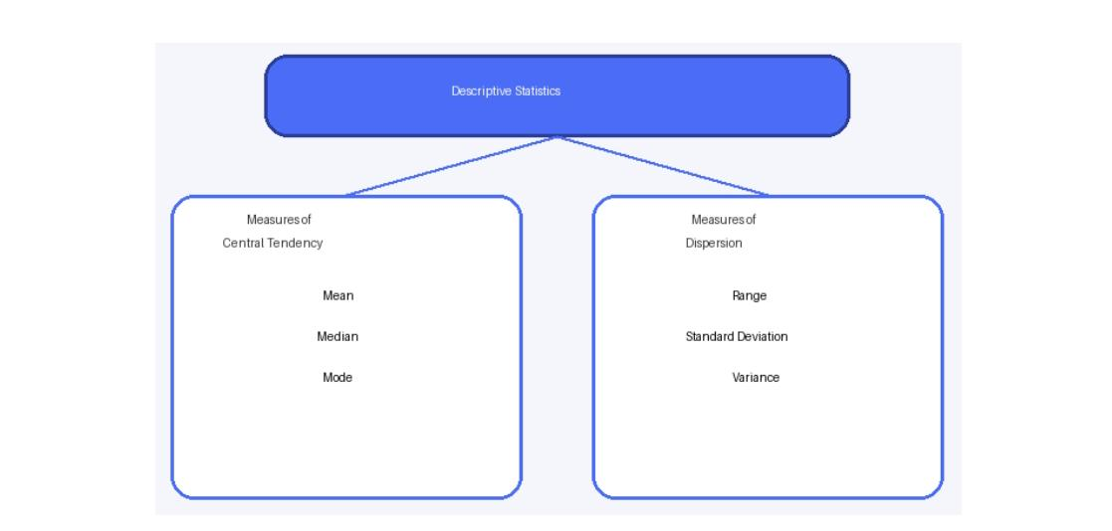
Descriptive Statistics
Descriptive Statistics classified into Measures of Central Tendency and Measures of Dispersion.
Measures of Central Tendency
Measures of Central Tendency is the statistical method used to find central or average value of a dataset. It includes Mean, Median, Mode.
1.Mean
The mean is the average value of a dataset.
Mean = Sum of all values /Number
Q1. The mark of 5 students is:
60, 70, 80, 90, 100
Calculate Mean
Ans: Mean Mark= Total Marks / Number of the Marks
=60+70+80+90+100/5
=400/5
=80
Mean Mark = 80
Q2. A company wants to know the average salary of the
employees.
Employee Salaries:
Rs.30000, Rs.35000, Rs.40000, Rs.45000, Rs.50000
Ans: Mean Salary= Total sum of the Salary / Number of the Salaries
= 30000+35000+40000+45000+50000
= 200000/5
Mean Salary = 40000
2.Median
The median is the middle value of a dataset when the values are arranged in ascending and descending order.
If the number of observations is even, the median is the average of the two middle values.
Q1. Dataset:
10, 15, 20, 25, 30
Find Median.
Ans: Median =20
Q2. Dataset:
10, 15, 20, 25
Find Median.
Ans: Median= 15+20/2
=35/2= 17.5
Q3. House prices: 10L, 12L, 15L, 20L, 1 Crore.
Find Median.
Ans: 15L
3.Mode:
The mode is the value that appears most frequently in a dataset.
A dataset may have:
One mode – Unimodal
Two modes – Bimodal
More than two – Multimodal
Q1. Dataset:
2, 4, 4, 5, 6, 7
Find Mode.
Ans: Mode= 4
Q2. Dataset:
S, M, M, M, L, L, XL
Find Mode.
Ans: M
Comparison between Mean, Median, Mode.
Measures | Meaning | When to Use
Mean | Average of all values | General analysis
Median | Middle Value | When data has outliers
Mode | Most frequent value | For categorical data or popularly

Measures of Dispersion
Measures of Dispersion is the statistical method used to show how much the data values are spread around central value.

1.Variance
How much the data values spread out from the mean (Average).
Q1. The mark of the students
10,12,14
Find Variance.
Ans: Mean= 10+12+14/3
=12

Value | Deviation(X-M) | Square
10 | -2 | 4
12 | 0 | 0
14 | 2 | 4
Variance= (4+0+4)/3
=2.67
2. Standard Deviation
Standard Deviation measures the average distance of each data values from the mean. It is the square root of variance.
Q1. Using previous dataset:
10, 12, 14
Variance= 2.67
S D= Root 2.67

